Risk Assessment for Victor Harbor DECD Aquatics 2013

Site: Encounter Lakes

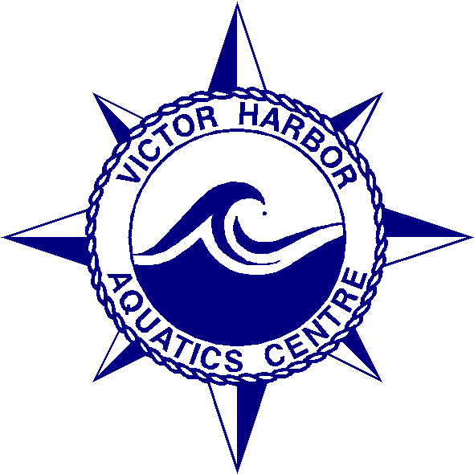

Victor Harbor DECS Aquatics
The Parkway
Victor Harbor
5211
(08) 85521166
Fax: (08) 85529291
Mobile: 0408847894

